EXERCISE NO:09
DATE:24/11/2020
AIM:
To Write a Python program to get a list of numbers of list and create a list of tuples having first element as the number and second element as the cube of the number. Next the list of tuples should be sorted in increasing order by the last element in each tuple from a given list of non-empty tuples.
PROGRAM:
n=int(input())
list=[]
for i in range(n):
a=int(input())
list.append((a,a*a*a))
print(list)
for i in range(0,len(list)):
for j in range(i+1,len(list)):
if(list[j][1]<list[i][1]):
temp=list[i]
list[i]=list[j]
list[j]=temp
print(list)

LINK:
http://103.53.53.18/mod/vpl/forms/submissionview.php?id=317&userid=1692
OUTPUT:
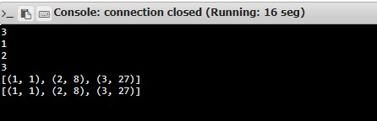

RESULT:
Hence , the Python program to get a list of numbers of list and create a list of tuples having first element as the number and second element as the cube of the number. Next the list of tuples should be sorted in increasing order by the last element in each tuple from a given list of non-empty tuples is printed.

